**PROJECT NAME:**

Uncovering the Gaming Indusry’s Hidden Gems : A Comprehensive Analysis of Video Game Sales

**TEAM MEMBERS:**

* **ARUN KUMAR . B**
* **PALPANDI .D**
* **KARTHIK.S**
* **VIGNESH.P**

**PROJECT REPORT**

* **INTRODUCTON**
* **Over view**

Video game sales analysis is the process of collecting and analyzing data about the sales of video

games in order to understand market trends and consumer behavior. This type of analysis can be

useful for a variety of purposes, including identifying the most popular games and genres, predicting

future sales, and developing marketing strategies.Video game sales analysis typically involves

collecting data from Kaggle sources. It was generated by a scrape of vgchartz.com. This data may

include information about the number of units sold, the retail price, and the platforms on which the

games are played. Once the data has been collected, it is typically analyzed using tableau. The

results of the analysis can be used to identify trends and patterns in the market, and to make informed

decisions about the development and marketing of video games.Video game sales analysis may be

conducted by game developers, publishers, retailers, and other industry professionals. It is an

* Purpose

it helps to understand the needs and preferences of

consumers and to identify opportunities for growth and innovation.

* Problem Definition & Design Thinking

2.1 Empathy Map :

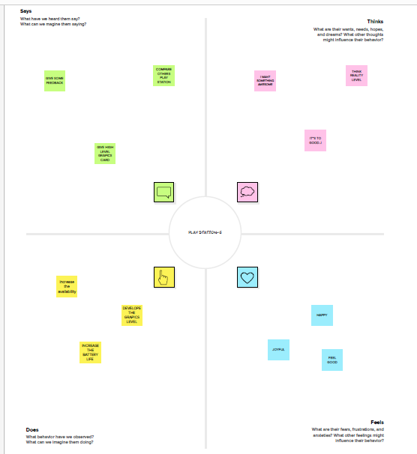

2.2 Ideation & Brainstorming Map Screenshot :

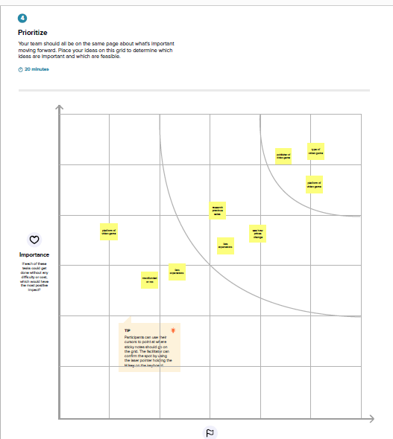

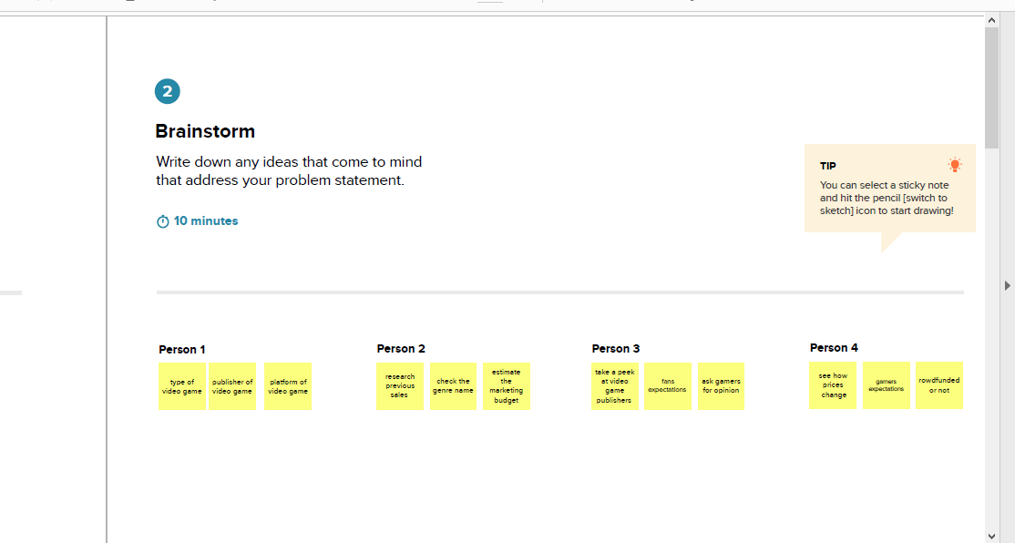

**3 . Result :**

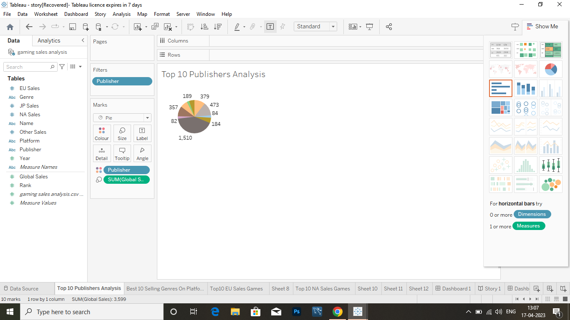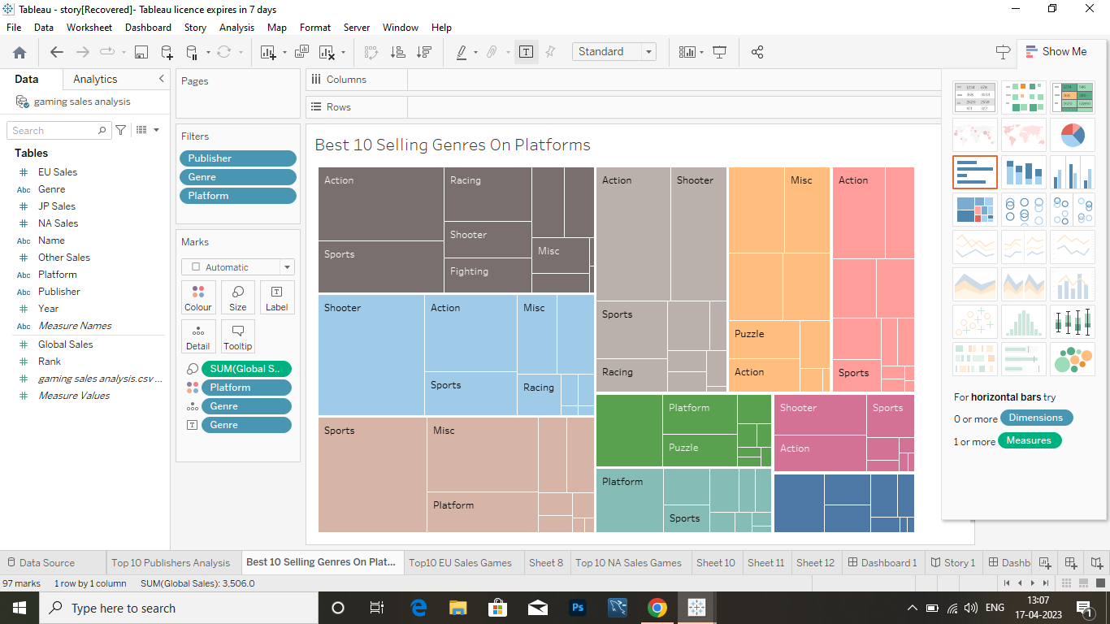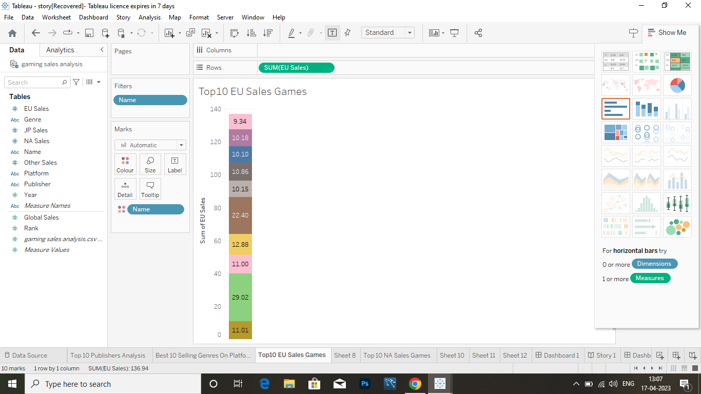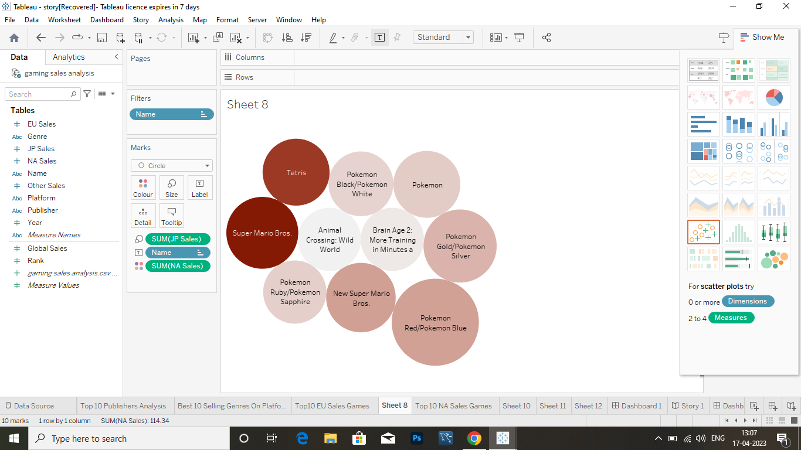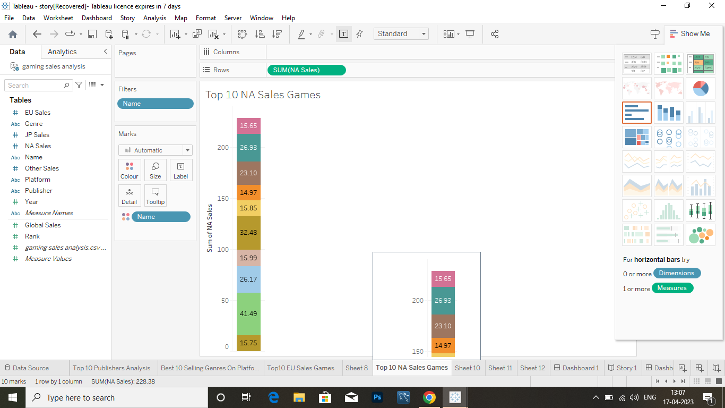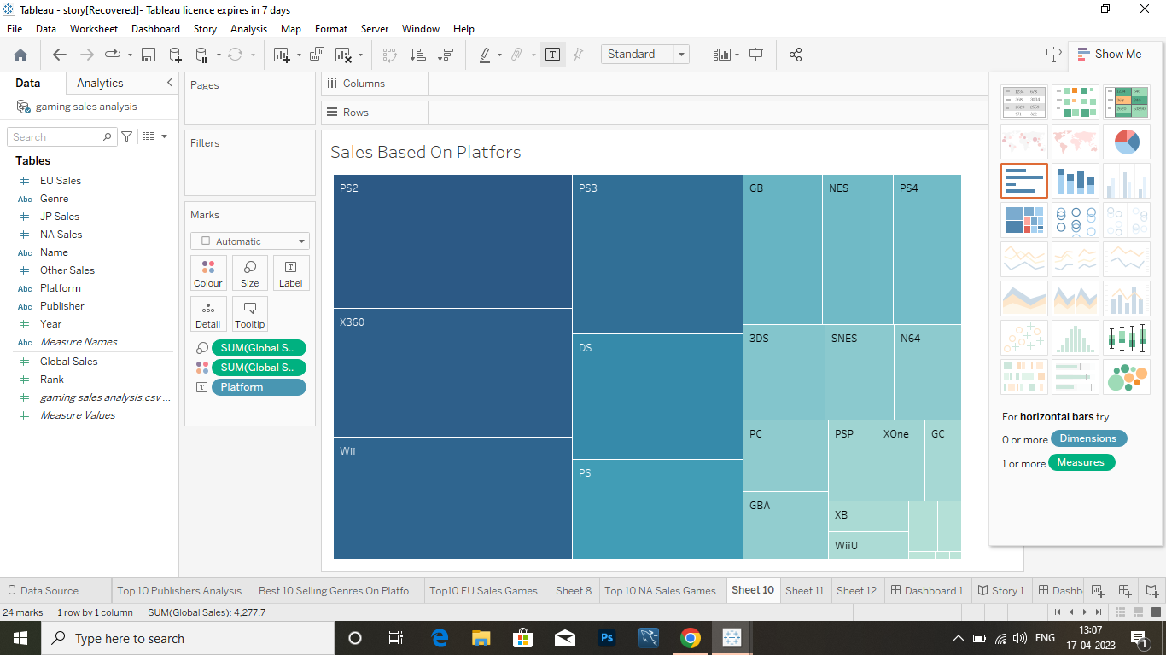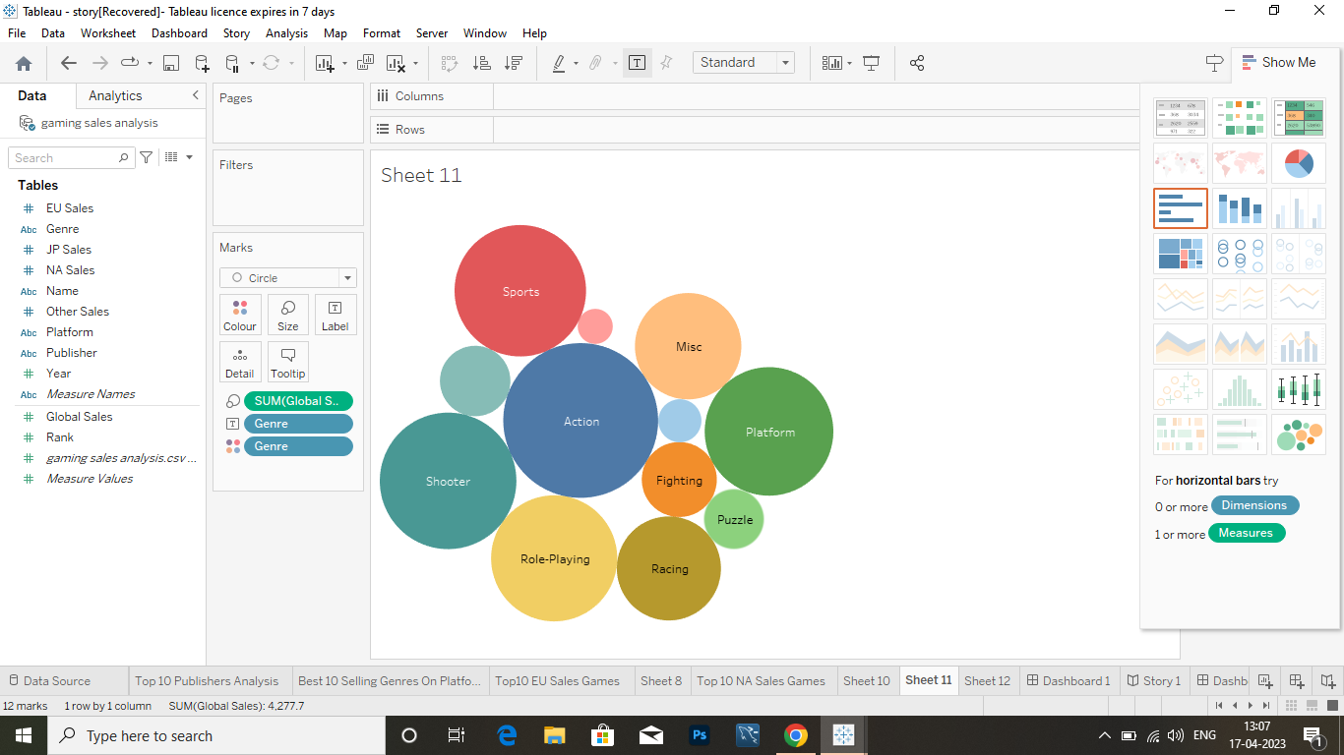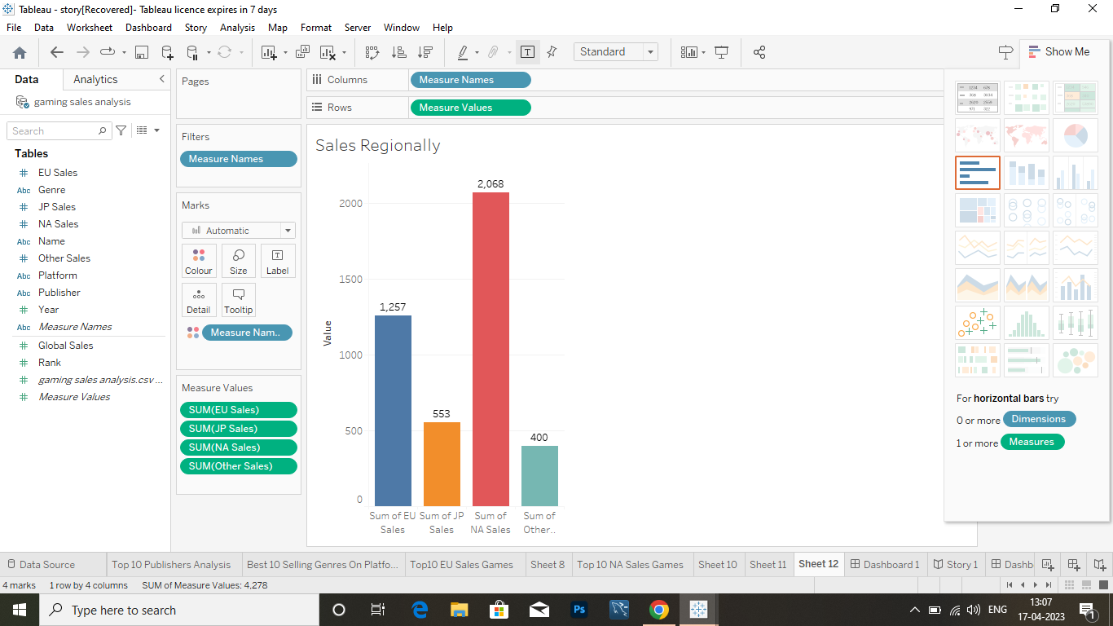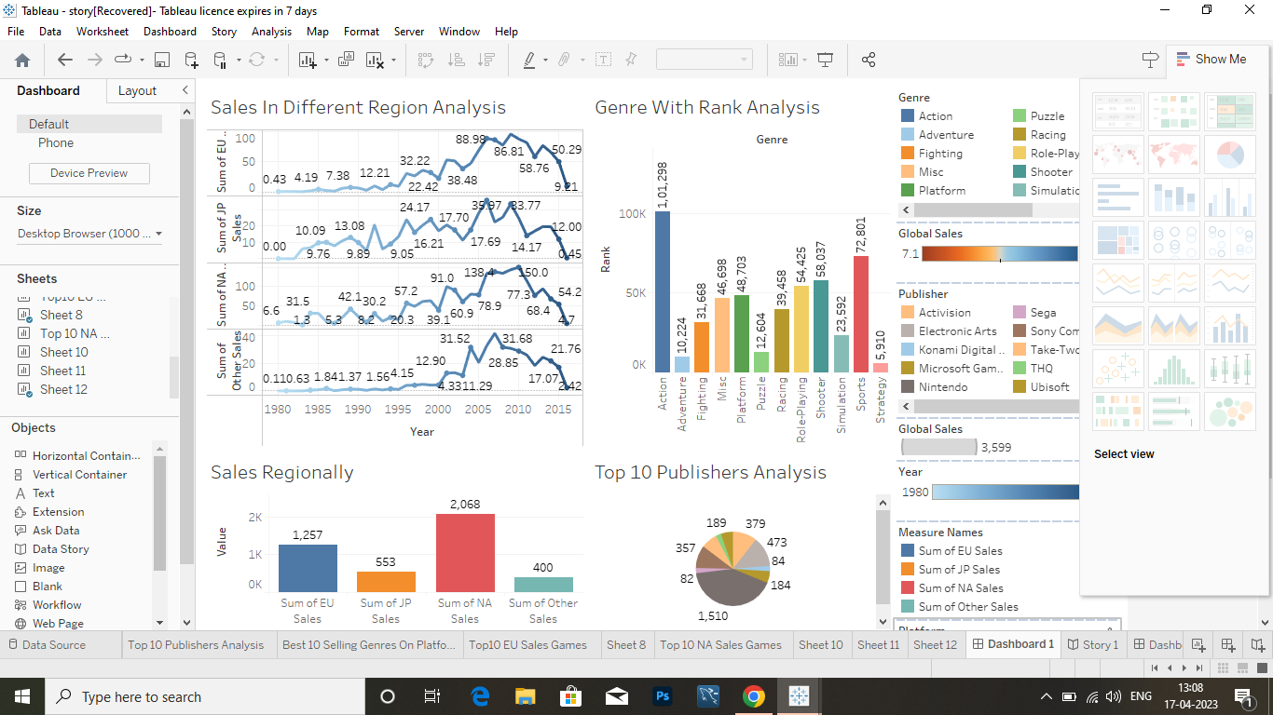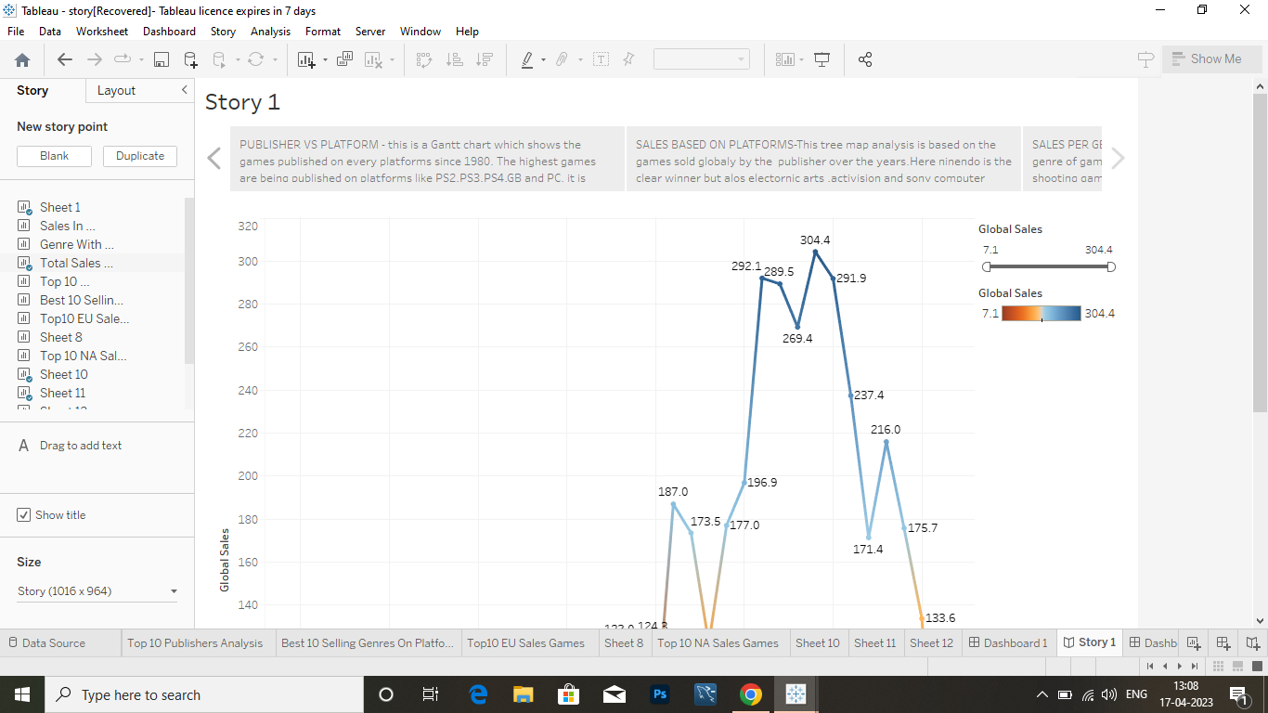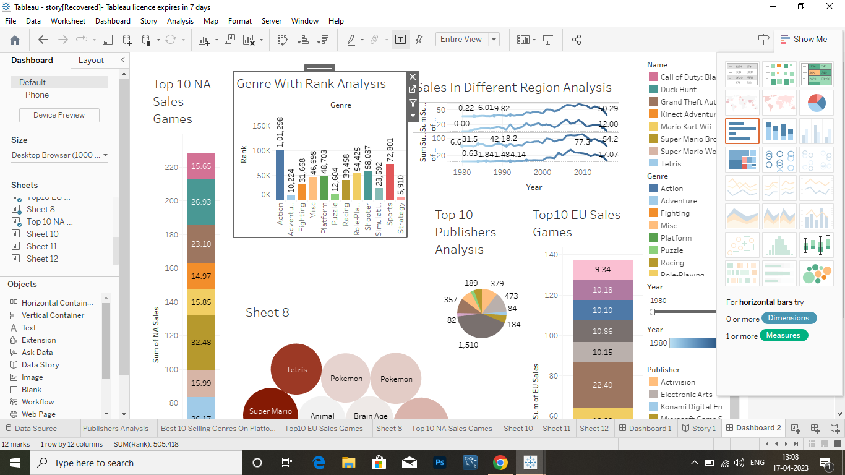

**4 . ADVANTAGES & DISADVANTAGES :**

we have detailed information on global video game sales, region-wise game sales, platform-based video game sales, etc. so that you can easily know which types of games can sell the most in the future. We hope that our detailed analysis of video game sales will be useful.

**5 . APPLICATIONS :**

This data may

include information about the number of units sold, the retail price, and the platforms on which the

games are played. Once the data has been collected, it is typically analyzed using

**6 . CONCLUSION :**

It is best opt for the games releasing in PC and also if you are looking for action games look for the publisher Nintendo as they have sold the highest number of games

**It is best opt for the games releasing in PC and also if you are looking for action games look for the publisher "Ninendo" as they**

**t is best opt for the games releasing in PC and also if you are looking for action games look for the publisher "Ninendo" as they have sold the h**

**It is best opt for the games releasing in PC and also if you are looking for action games look for the publis It is best opt for the games releasing in PC and also if you are looking for action games look for they have sold**

**7 . FUTURE SCOPE :**

significant here is that war games are the best sellers in both regions, Na and Eu. Following these, let's see the report on the top ten best selling games in jp. In this region games like pokemon gold, super mario bros and animal crossing :wild world were sold.

**8 . APPENDIX :**

**Source code**

file:///C:/Users/MILKY/Videos/Captures/Uncovering%20the%20Gaming%20Industry_s%20Hidden%20Gems%20A%20Comprehensive%20Analysis%20of%20Video%20Game%20Sales/index.html